**Neko Fruits (In-dev name)**

**High Concept**

Neko Fruits is a casual game, the player takes the role of a little catwho must eat all the fruits which are falling down from the sky taking care that none of these fruits touch the ground.

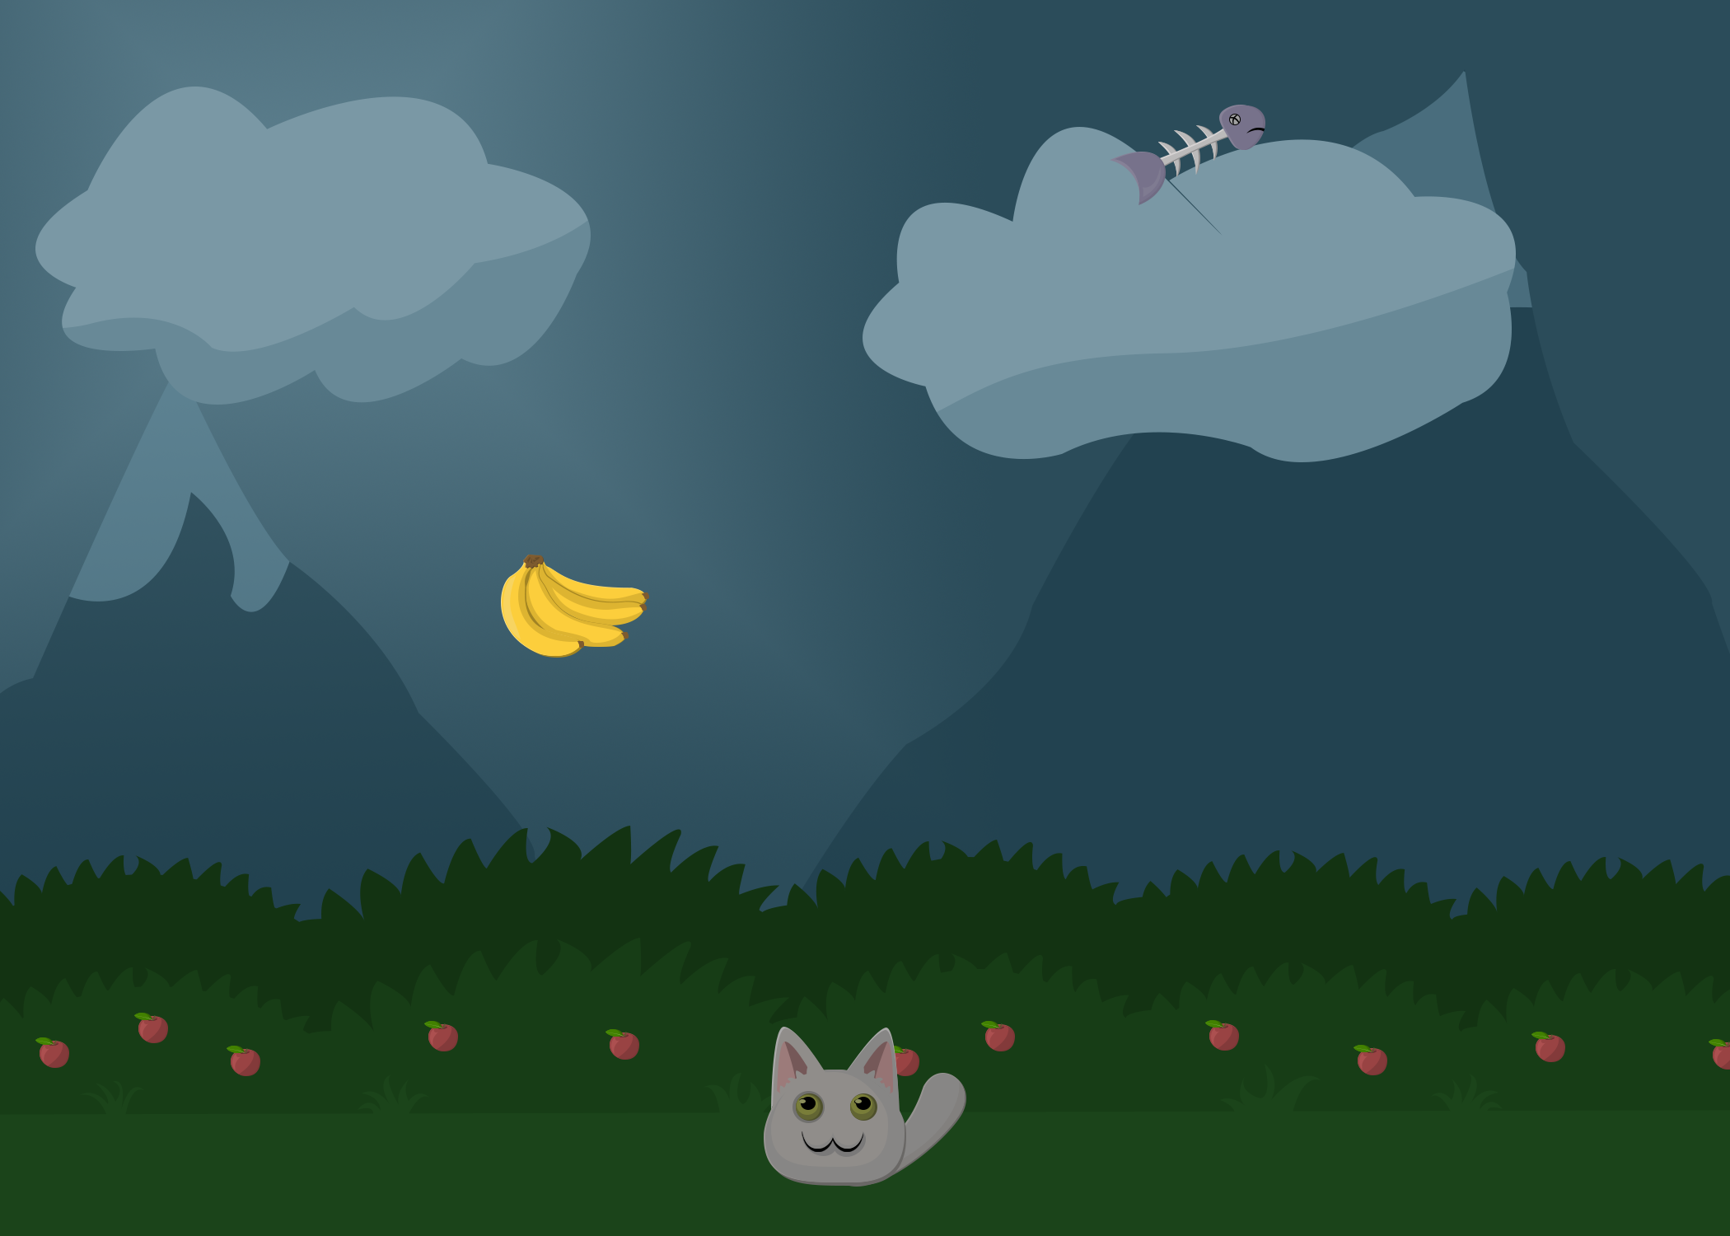

**Features**

* Simple mechanics gameplay style.
* Has not age range for playing, everyone can play it!
* Short duration of the gameplay
* Cute main character that everyone will love

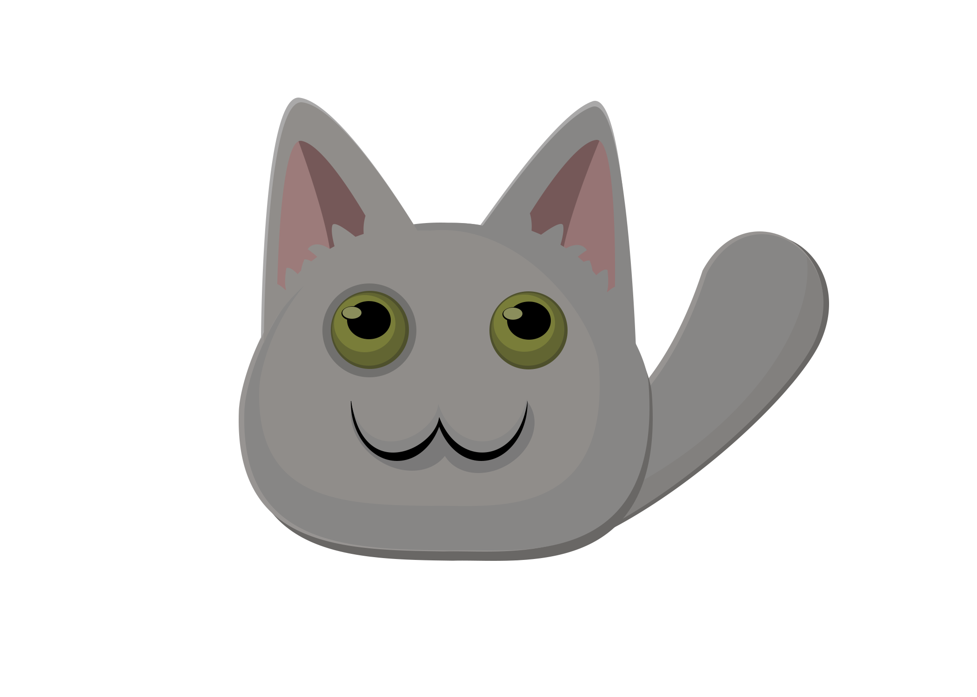

**Overview**

Neko Fruits is a casual game style with easy and short gameplay, with attractive cartoon-like style when the player takes the role of a little cat who must eat all the fruits which are falling down from the sky taking care that none of these fruits touch the ground.

However, not all the things that falls down from the sky are edible, also having some poisonous dishes, like fish.

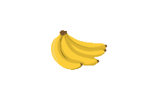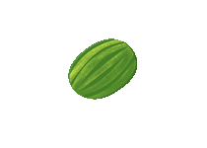

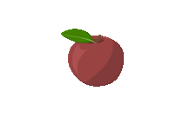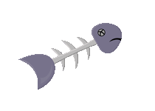

**Player Motivation**

The main motivation for a player is to spend some time for relaxing and go out from the daily life to an alternative world where cats are running happy across the field eating fruits that fall from the sky.

**Genre**

Casual game

Platforms

PC

**Target Customer**

Neko Fruits is intended to be played by for casual gamers, however it can be played by anyone (it has no age range limit!).

**Competition**

* Any other casual game with simple gameplay

Unique Selling Points

* Simple and nice graphics
* Cute main character
* Anyone can play it
* Does not require complex skills